Focus on Ukraine
July 9 – 15, 2012

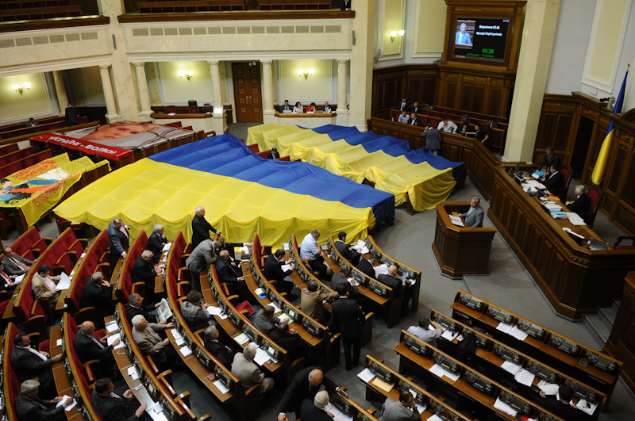

TABLE OF CONTENTS

І. Overview of political
events of the week……………….……………......….……....…3
II. Analytical Reference……………….…….…………….……….5

Democratic processes
The language NON-law-a litmus test of the internal political situation in Ukraine...............................................5

І. Overview of political events of the week

Demonstrations continue all across Ukraine against the law on language policy, mainly in Lviv, Kyiv, Cherkasy and Ternopil. The demonstrators for preservation of the Ukrainian language were forced out from the square in front of the Ukraine House. The passage of the demonstrators was blocked by turnstiles put up due to renovations.
July
9
Members of the opposition party paid a visit to the Ukrzaliznytsia Central Clinical Hospital in Kharkiv, where ex-premier Yulia Tymoshenko is being treated in response to information that she may be under threat of certain illegal acts being committed against her. In response Head of the Kachaniv Correctional Facility Ivan Pervushkin said the ex-premier will not be forcibly escorted to court.

Hunger strike activists are demanding that the Verkhovna Rada abrogate the adoption of the bill “On the Principles of the State Language Policy” by 12:00 pm on July 13. In addition to that, the strikers demand from President Viktor Yanukovych that he veto the bill if it is submitted to him for signing.
July
10
The Kharkiv City Council supports the law “On the Principles of the State Language Policy”. The city council considers this law a legal mechanism for resolving the language problem at the national and regional levels.

Demonstrations against the law on the state language policy continue, even abroad in the Czech Republic and France.
July
11

The OSCE Parliamentary Assembly is urging Ukraine to review articles 361 and 365 KK, guarantee medical aid to Yulia Tymoshenko, Yuriy Lutsenko and Valeriy Ivashenko and grant them permission to run in the parliamentary elections in 2012 this October. This was stated in the text of the resolution approved at the meeting of the OSCE Parliamentary Assembly on July 11, 2012.

The Higher Specialized Court of Ukraine postponed the review of cassation of the sentence of Yulia Tympshenko in the gas case passed down on September 16. The judges substantiated their ruling arguing it would “ensure objectivity in the case”. The judge said he would partially allow the petition of state prosecutors and postponed the court session until he receieves the necessary information about Tymoshenko’s state of health.
July
12
The Constitutional Court of Ukraine deemed the clause on election and dismissal of the head of the Verkhovna Rada in the law of Ukraine “On the Procedures of the Verkhovna Rada” unconstitutional. Now the appointment or dismissal of the VR speaker will be executed through open voting (as opposed to secret balloting) based on a simple majority (earlier the requirement for this was 226 votes based on 300 ballots received). This means that the pro-government party can dismiss VR Speaker Volodymyr Lytvyn for not signing the language law.
Viktor Yanukovych met with Vladimir Putin in Yalta. There the two heads of state signed 8 sectoral agreements and memorandums, a declaration on the content of Ukrainian-Russian strategic partnership and two joint statement. The anticipated signing of the most important agreement on the delimitation of the Azov-Kerch straits did not take place.
Viktor Yanukovych and Vladimir Putin met in Yalta. There they signed 8 sectoral 8 agreements and memorandums, a declaration on the content of Ukrainian-Russian strategic partnership and two joint statements. The anticipated signing of the most important agreement on the delimitation of the Azov-Kerch straits did not happen.

II. Analytical Reference

- Democratic processes

THE LANGUAGE NON-LAW – A LITMUS TEST OF THE INTERNAL POLITICAL SITUATION IN UKRAINE

The language issue has traditionally been the most popular among Ukrainian politicians prior to elections. They successfully managed to manipulate the language issue, particularly on the backdrop of the status of the Russian language in Ukraine by artificially aggravating it during all the previous election campaigns. But in preparations for the upcoming 2012 elections the pro-government majority in the current parliament switched from words to action by adopting in the second reading the Law of Ukraine “On the Principles of State Language Policy” on July 3, 2012.

What was the purpose of adopting the language law?
Who needs this law more: the people or the government?
What could be the repercussions of this law?

MPs HAD NO RIGHT TO VOTE

It is obvious that the law on language policy passed by the Ukrainian parliament was a gross violation of the Constitution of Ukraine and the Law of Ukraine “On the Procedure of the Verkhovna Rada of Ukraine”. The procedural violations were committed in a number of aspects.
First of all, the specialized committee did not submit the bill on this issue for consideration by the parliament in the second reading and MPs did not receive the bill revised by the committee for their perusal. In other words, the MPs in principle did not have an issue to vote on as nobody had the right to put this bill up for voting.
Secondly, the speaker of the parliament announced voting for the bill, but failed to state which version was put up for voting, meaning it was unclear to the MPs whether they were voting for the initial version or the revised one (though officially the bill was never revised).
Thirdly, and the main thing, was the fact that the Constitution of Ukraine was violated, specifically Article 84, which stipulates that members of parliament must show up in person to cast their. But in the case of this particular law and many others passed, this norm was violated. Indeed, when the session hall of the VR is half full the MPs vote not only for themselves but also for their colleagues that hand over to them their voting cards. Indeed, while those MPs who are absent in the parliament to cast their vote as they engaged in their own personal business during the process of voting managed to show up to collect their monthly salary. After all, an MP earns a minimum of UAH 17,000 per month or approximately EUR 1,790 without even having to show up in the parliament, while the official minimum wage in Ukraine is a miserly UAH 1,094/month for which the average Ukrainian must work a full working day. So, on July 3 information was placed on the voting board of the VR that during voting for the law on languages 248 MPs voted in favor, while a video recording by journalists showed that such a number of MPs werer not even present in the parliamentary session hall.
Besides that, the content of the adopted law contradicts the Constitution of Ukraine, which stipulates that the Ukrainian language is officially used in the system of justice, business and in all bodies of state power. However, the new law does allow for full substitution of the national language by other languages without obstacles.
While an analysis of legal coalitions is not the subject of this article and cannot be explained in such a format, in this context the main conclusions are that the activities of the parliament breeched the procedures stipulated by the Constitution and legislation, meaning that the law on languages are unconstitutional and illegitimate.
Be that as it may, nobody pays attention to this fact. Moreover, with the help of the Constitutional Court pro-government deputies managed to achieve the acknowledgement of the unconstitutionality of those clauses in the Procedures of the VR that block the majority from dismissing VR Speaker Volodymyr Lytvyn, who refused to sign the language law. In short, both the law and the court backed the pro-government forces.

LANGUAGE ISSUE IS NOT THE MOST PRESSING PROBLEM IN SOCIETY
It is immediately worth emphasizing that the objective of the adopting this law was first and foremost to change the status of the Russian language. The Party of Regions long ago promised its mostly Russian-speaking electorate in the eastern part of Ukraine to grant Russian the status of the country’s second official language. De facto the Russian language can indeed be granted such status. It makes no difference it is formally named – the second or regional language as it is named in the adopted law. The main thing is that the Russian language can now squeeze the Ukrainian language out of use in public.
Members of the party in power officially confirm that they promised to resolve the language issue and they did so. However, this begs the questions: Do Ukrainians really need this law and is it really a priority? The answer is simple – no. According to the results of research conducted by the I. Kucheriv Democratic Initiatives Foundation, and the O. Razumkov Center from May 31-June 6, 2012 prior to the upcoming parliamentary elections, such issues as unemployment, overcoming the economic crisis and a raise in wages and salaries are the most pressing for Ukrainians. The issue of the status of the Russian language is supported by only 3.9% of the population. This figure is too eloquent to comment whether Ukrainians, including those that speak Russian, on the issue of the Russian language. So, why was there such a fuss and so many violations during the adoption of this law? Who really needs it? The answer is that the Party of Regions needs this law. Its motivation is simple: first of all, an artificial informational decoy must be created to divert the attention of society from the most pressing problems, mainly economic, seeing as many people are disappointed with the policy of the current government and its reforms. Secondly, the government needs to immediately mobilize its forces, organize its electorate before the elections and draw a line between its proponents and opponents. The actions of politicians are a response to satisfy the needs of the people and their own political interests and ambitions in the future elections. The interests of people have no meaning at all here. And while effective economic management would be more beneficial for both the eastern regions of Ukraine, where the population is largely Russian-speaking, and the western Ukrainian-speaking regions, this is too much trouble for Ukraine’s MPs.

PROTEST REACTION OF THE PEOPLE
The illegitimate adoption of the law sparked a wave of protests all over Ukraine. Demonstrations against the law started in downtown Kyiv and certain participants announced they will go on a hunger strike in protest of the law.
The demonstrators were of different colors united by a mutual objective: people’s deputies, journalists, civic and political leaders and average citizens demanding the abolition of the odious language law that they consider an encroachment on the Ukrainian language that should be the only state language and is protected by the Constitution.
This act of protest set off a wave of demonstrations in other cities all over Ukraine: Kharkiv, Donetsk, Dnipropetrovsk, where by the way the local residents are predominantly Russian-speaking, Ivano-Frankivsk, Cherkasy and other cities. Even Ukrainians that live abroad held rallies in support of the Ukrainian language. The government reacted by sending units of the Berkut law enforcement division to the demonstration in front of the Ukraine House in Kyiv, which resulted in clashes between the demonstrators and the riot police.
Both sides suffered injuries and the Prosecutor’s Office of Kyiv immediately opened several criminal cases regarding these clashes and the culprits in these protests are representatives of the protest camp. The Berkut detachment applied disproportionately greater force against the demonstrators, which is a clear indication that the ruling power does not need any acts of protests on the threshold of the upcoming elections and must show the electorate that the situation in Ukraine is calm and stable.
In a country in which protests under such slogans as “Ruin is overcome!” and “Championships advance, achievements remain” were held two years ago prior to the presidential elections that are against government policy and the people were promised “Improvement of life today” should not be allowed.
At the moment there are considerably less people protesting in front of the Ukraine House and though there were less than 1,000 protesters from the start, the main demonstration is over. Perhaps due to the relatively low probability of serious resistance of the people the government manages to pass such laws.

Conclusions
The adoption of the law “On the Principles of State Language Policy” is an illustrious example of the violation of the laws of Ukraine and the Constitution on the part of deputies, the inconsistency of their initiatives regarding the most urgent needs of the people and the realization of their personal interests with the help of a deputy mandate that are not in the interests of the people dictated by the need to mobilize the electorate and win the parliamentary elections at all costs.
As it turns out, the language law was unnecessary when total power is in the hands of one force and even the Constitutional Court cannot reject it. So, once again the green buds of a legitimate state in Ukraine have been trampled into the earth.

“Focus jn Ukraine” – weekly informational-analytical news bulletin prepared by the Ilko Kucheriv Democratic Initiatives Foundation (http://dif.org.ua).

DIF Analysts:
Iryna Bekeshkina
Oleksiy Sydorchuk
Julia Ilchuk
Maria Zolkina

Editor-in-chief:
Iryna Filipchuk

